Northern Cross Country Relay Championships

incorporating The Cutler’s Relay, South Yorkshire Cross Country Relay Championships & The Yorkshire Veterans AA Cross Country Relay Championships
(Under UKA Rules)
Permit Number 2014080

at
Graves Park, Sheffield
Saturday 18th October 2014
Supported by the A.A.A.

Northern Athletics
In association with
Sheffield Running Club
Presents
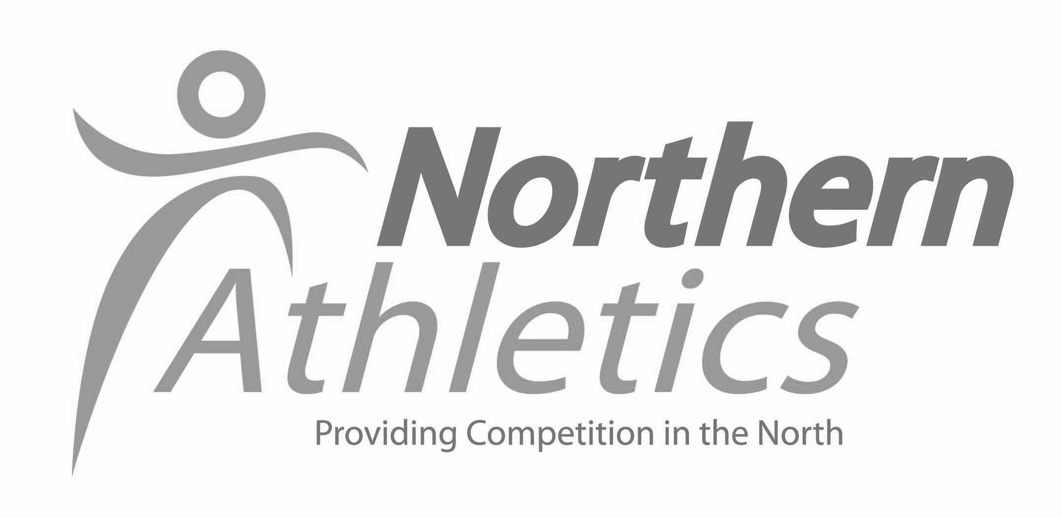

Timetable of Events

Time | Event | Stages | Distance
11.00am | Under 17 Women | 3 | 2300m
11.05 | Under 17 Men | 3 | 2300m
11.35 | Under 11 Girls | 3 | 1500m
11.40 | Under11 Boys | 3 | 1500m
12.00pm | Under 13 Girls | 3 | 1800m
12.05 | Under 13 Boys | 3 | 1800m
12.40 | Under 15 Girls | 3 | 2000m
12.45 | Under 15 Boys | 3 | 2000m
13.15 | Masters/Senior Women | 3 | 2 miles
14.15 | Masters Men | 3 | 2 miles
14.15 | Senior Men  ‘The Cutlers Relay’ | 4 | 2 miles

To use our online entry system please go to:
www.race-results.co.uk and follow the instructions.

CLUB COLOURS & VEST/CROP TOP ALL OF THE SAME DESIGN MUST BE WORN

Clubs may submit a maximum of 9 names per team (3 Stage) or 12 names per team (4 Stage) There is no restriction as to the number of teams a club may enter except in U11 event where a maximum of 2 teams per club will be accepted.

Closing date for entries 10th OCTOBER 2014
Northern Athletics, 7a, Wellington Road East, Dewsbury WF13 1HF
Tel: 01924 457922. E-mail: info@northernathletics.org.uk.

Age Groups
U11 Competitors 9 &10 years on day of competition.
U13 Competitors 11years on the day of competition & 12 years on 31st August/1st September 2014
U15 Competitors 13 & 14 years on 31st August / 1st September 2014
U17 Competitors 15 & 16 years on 31st August / 1st September 2014
Senior Competitors 17 years and over on 31st August / 1st September 2014
Masters All age groups – Competitors must be at least 35 years and the correct age for the appropriate category on the day of competition.

Entries
All entries must be submitted through the Northern Athletics website online entry system
Entry fees as below.
U17/U15/U13 /U11 £18.00 per team
All Masters & Senior Women £18.00 per team (3 Stage)
Senior Men £24.00 per team (4 Stage)

Conditions of Entry
- Entries from Clubs will only be accepted if the Club is currently affiliated to England Athletics and based in the Northern Athletics area.Team members MUST be first claim members of that club AND registered with England Athletics. England Athletics Registration Numbers MUST be included. Athletes without registration numbers will not be accepted. (U11 athletes are exempt from this condition)
Any Foreign Athletes in the team MUST also be currently registered with UKA as Foreign Athletes. All team and athlete affiliation will be verified prior to the event. A club can enter as many foreign athletes as they wish but only 2 may run in each declared team
- Clubs entering Yorkshire Veterans Championships must be affiliated to YVAA.
- Entries must be submitted via the official online entry system and the correct fees paid at the time of entry.
- Late & incorrectly submitted entries will be rejected by the Sportsoft entry portal
- Acknowledgement of entry will be by return email and final instructions will be emailed prior to the event.
- Clubs that run ineligible or unregistered runners will be disqualified and may have their entry refused for the 2015 event
- All Northern Athletics Clubs affiliated to England Athletics are eligible to enter the 2015 National Championships

Prizes & Awards
Northern Championships
Championship medals will be awarded to the first 3 ‘A’ teams to finish (male & female) in each age group excluding U11 age group. (Non Championship event; Awards will be made to the first three U11 teams).

South Yorkshire AA Championships
Championship medals will be awarded to the first 3 ‘A’ teams to finish (male & female) in each age group (Minimum of 4 teams per age group) entered in the South Yorkshire Championships.

Yorkshire Veterans AA Championships (for YVAA affiliated clubs only)
1st 3 teams in M35-39, 40-49, 50-59, & W35-44, 45-54.
1st 2 teams in M60-69. 1st team only in W55+ & M70+

